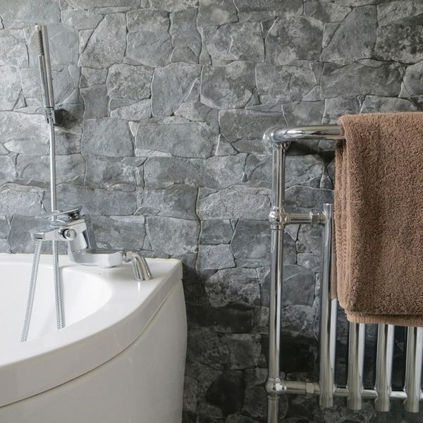**Stacked Slate Stone:**

## **Product Description**

Create the illusion of decorative drywall in your home with these Stacked Slate Stone Effect Tiles. They have a textured finish; perfect for adding character into any room throughout the house. They belong to our range of Cusco Dry Stone Wall Effect Tiles and are perfect for creating a feature wall either inside the home or outside in the garden. They have a matt finish. They're suitable for use in both internal and external wall spaces. For a grout that matches the faux grout joint contained within these tiles, try our [Ultracolour Plus, Black Tile Grout](https://www.wallsandfloors.co.uk/catrangetiles/tile-grouts/mapei-grouts/mapei-ultracolour-plus-black-120-grout/17841/).

## **Product Info**

* Product ID: 15311
* Tiles Per SQM: 4.6200046200046
* Sale by: Per SQM
* Size: 650x333x10mm
* Weight: 4.20 KG
* Material Type: Porcelain
* Finish: Matt
* Colour: Grey
* Suitability: Walls
* Grade: 4
* Rectified Edge: No
* Underfloor Heating: No
* Thickness (mm): 10